NASA - PDS Cassini Propeller Hunter C++ and Java Code Refactoring Assembly Deployment Guide

Revision History
Author | Revision Number | Date
yedtoss | 1.0 | 03/29/2015

Deployment Instructions 3
1.Organization of Submission 3
2.Application Setup 3
3.Third Party Libraries 3
4.Compilation Instructions 3
MAC OS X 3
LINUX 8
5.Usage Instructions 9
Run any of the binary with -h as option to see how to use it. 9
Note that all options are optional, if you don't provide it default value will be used 9
6.Verification 9
Porting all code to C++ 9
Separate in three programs 9
Accuracy 9
Radius and Longitude 11
Command Line options and threading 11
Logs and Error Messages 11
Splitting code in Multiple files 11
Speed Comparison 11
7.Resource Contact List 12

Deployment Instructions

Organization of Submission
docs/ Contains this deployment guides
src/ Contains the source code
test_files/ Contains test files

Application Setup

MAC OS X 10.10 64 bits
Linux/Ubuntu 14.04 64 bits
g++ 4.9
Cmake >= 2.8

g++ lower than that won't work

Third Party Libraries

Easyloggingcpp version 9.80 https://github.com/easylogging/easyloggingpp/releases
Tclap version 1.2.1 http://sourceforge.net/projects/tclap/files/
Cereal version 1.1.1 http://uscilab.github.io/cereal/
CSV commit aa9a4cc44b3e786a4e13a04c054a95c669df88ab https://github.com/jay/CSV

Compilation Instructions

MAC OS X

First we need to install g++ 4.9 then cmake and after that we can compile and get the binaries.

Here is how to do it

To deploy the application in OS X, perform the following step:
- Install brew: ruby -e "$(curl -fsSL https://raw.githubusercontent.com/Homebrew/install/master/install)".
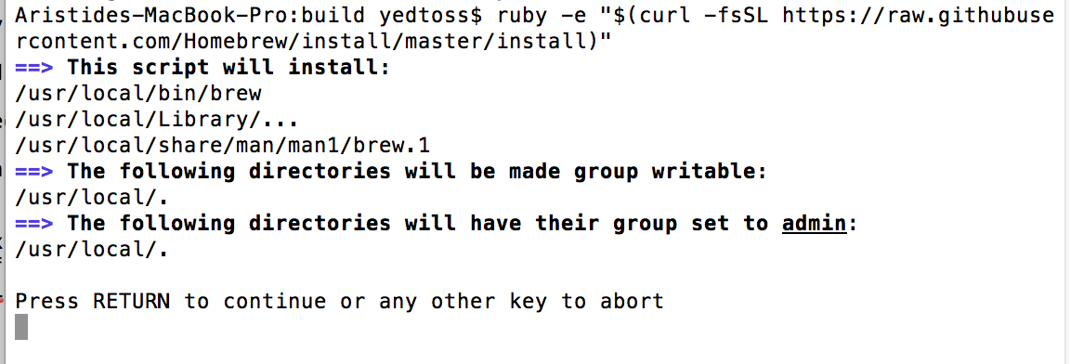
If you do not have the Xcode command-line tools, you will be prompted to install them as shown below.

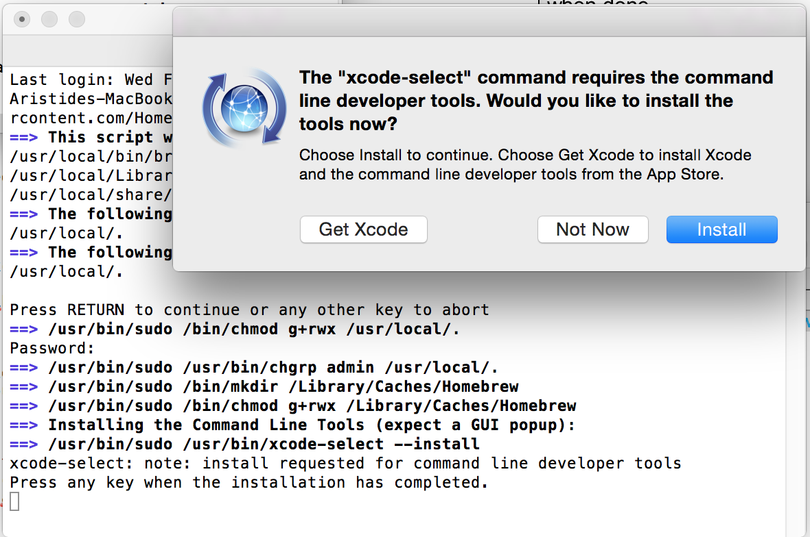

Install the software and make sure the installation is successful as shown below.
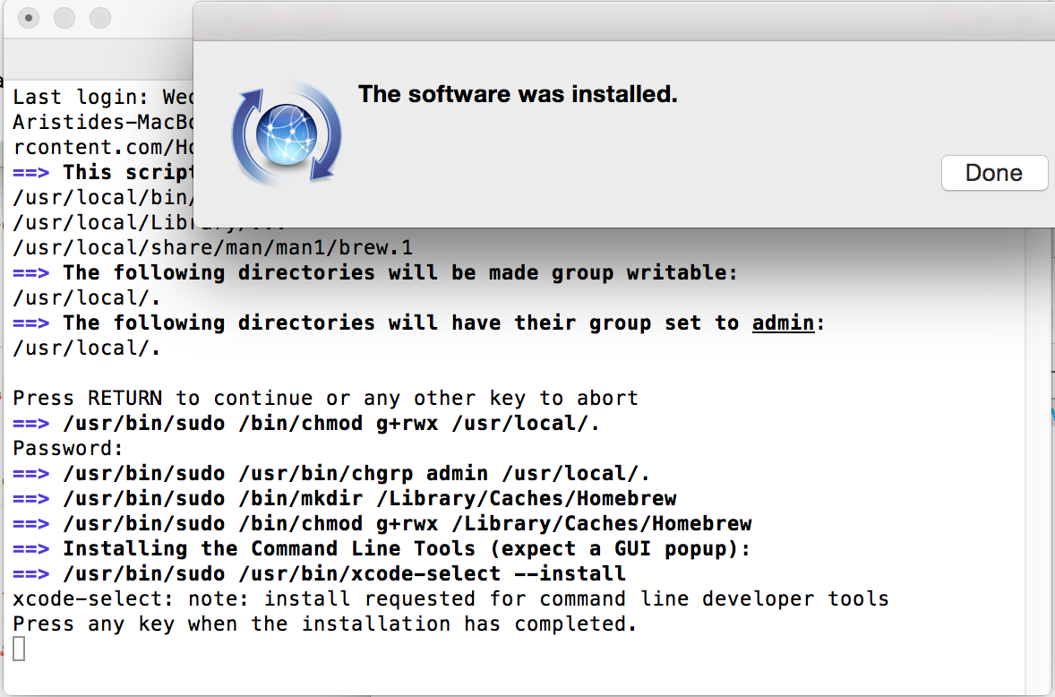

Press any key. It is possible that you will see an error about the active developer path:

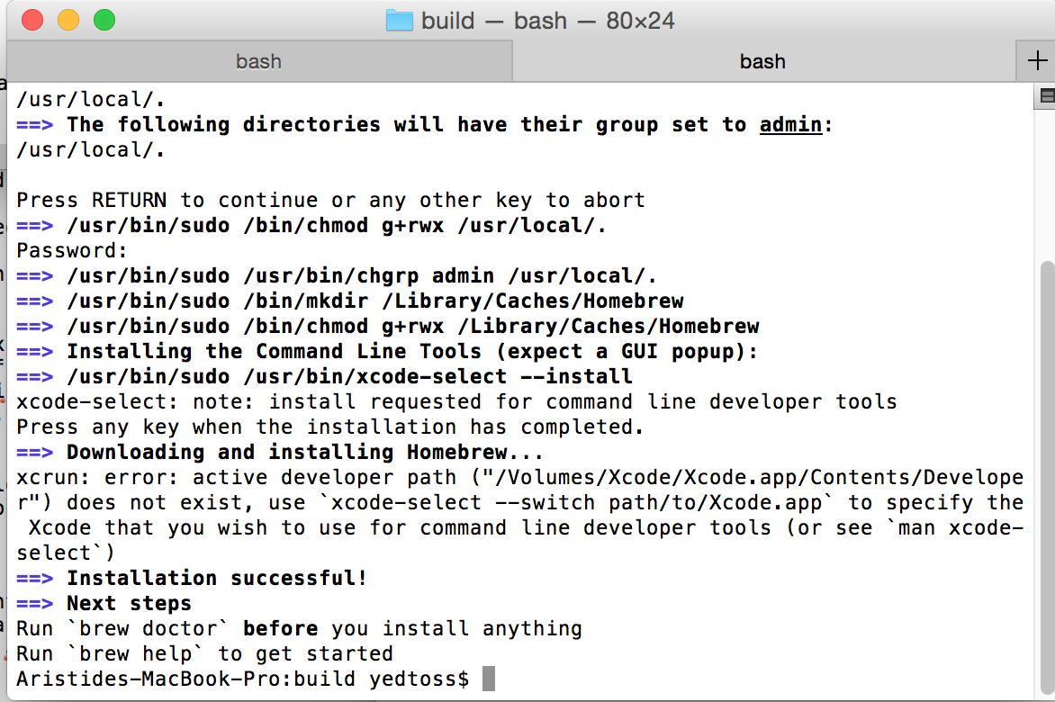

If you do get that error, you can correct it by specifying the version of Xcode to use:
sudo xcode-select --switch /Applications/Xcode.app

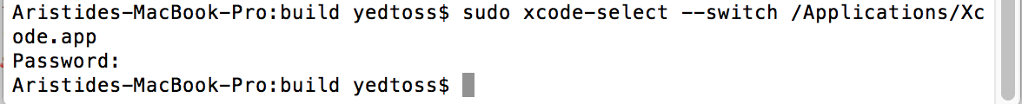
Now run this command:
brew doctor

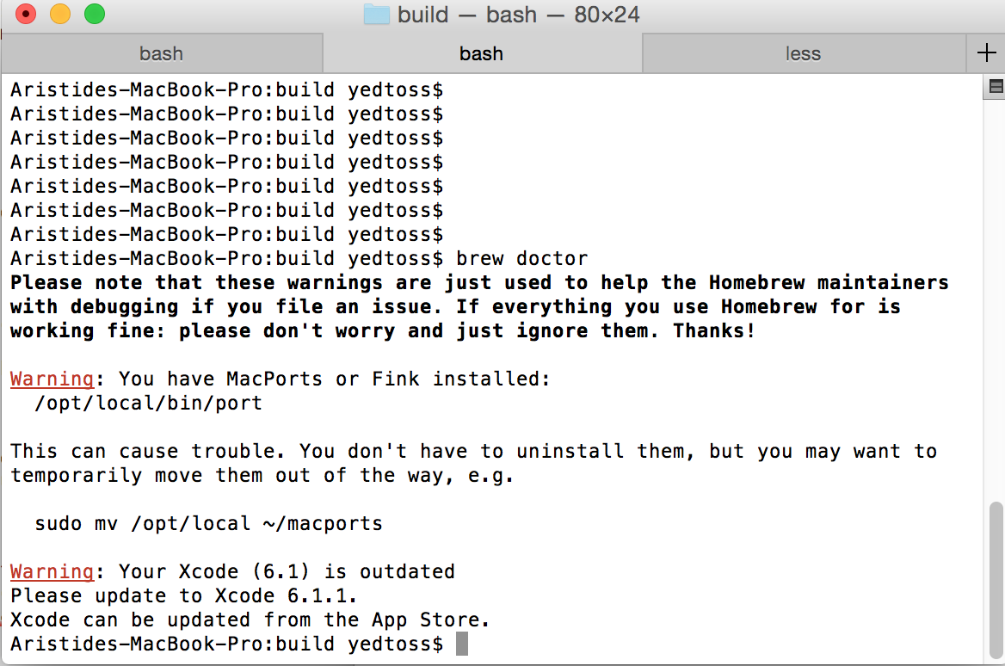

Ignore any warnings that may appear.
Install GCC 4.9:
brew install gcc
You can ignore warnings about multilib.
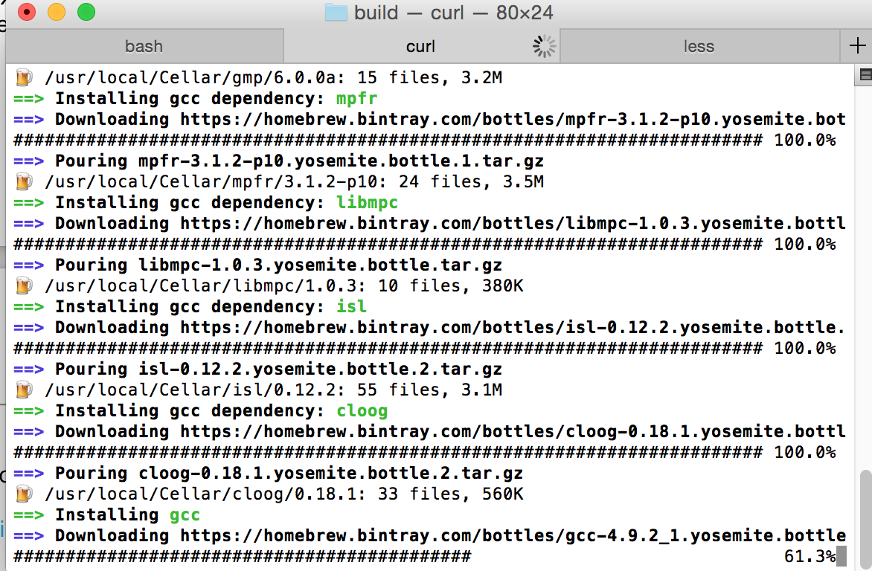

Install CMake:
brew install cmake

- Now create a directory $BUILD outside the src/ directory of the submission and enter that directory
- Run cmake src -DCMAKE_CXX_COMPILER="g++-4.9"
- Run make
- You will get three binaries in the $BUILD directory named: PropellerTrain, PropellerTest and
PropellerStats

LINUX

First we need to install g++ 4.9 then cmake and after that we can compile and get the binaries.
Here is how to do it for Ubuntu 14.04:

Run sudo add-apt-repository ppa:ubuntu-toolchain-r/test

Run sudo apt-get update

Run sudo apt-get install g++-4.9
Run sudo apt-get install cmake

- Now create a directory $BUILD outside the src/ directory of the submission and enter that directory
- Run cmake src -DCMAKE_CXX_COMPILER="g++-4.9"
- Run make
- You will get three binaries in the $BUILD directory named: PropellerTrain, PropellerTest and
PropellerStats

Usage Instructions

Run any of the binary with -h as option to see how to use it.

Note that all options are optional, if you don't provide it default value will be used

It is expected to first run PropellerTrain then in second, PropellerTest and finally PropellerStats.

Verification

Porting all code to C++

It is easy to verify that all code have been ported to C++

Separate in three programs

It is easy to see that the code has been splited in three programs. Check their help to see how to use them

Accuracy

Run the previous code (Get it from contest specification and there is a README, Read also contest specification for where to put the testing files) like that:

java -jar PropellerDetector.jar ./PropellerDetector-1 quick_index.lbl quick_index2.lbl full_ground_truth.csv -v

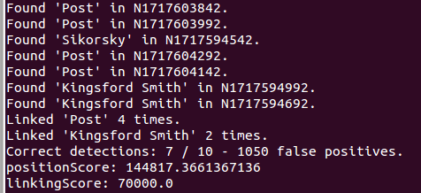

Now run in order

PropellerTrain -t quick_index.lbl -g full_ground_truth.csv -m training_model.dat
PropellerTest -t quick_index2.lbl -g full_ground_truth.csv -m training_model.dat -o candidates.dat
PropellerStats -o candidates.dat

Run these commands from the test_files/ directory. And make sure to download and extract both https://drive.google.com/file/d/0B-0bDf2WzZsgXzZVMGNJaGhIS28/view?usp=sharing

and https://drive.google.com/file/d/0B-0bDf2WzZsgUmt4NXlMTk5wdFU/view?usp=sharing

such that test_files/eval and test_files/contest directory exists.

You will notice that both previous code and current code give as result in the output:

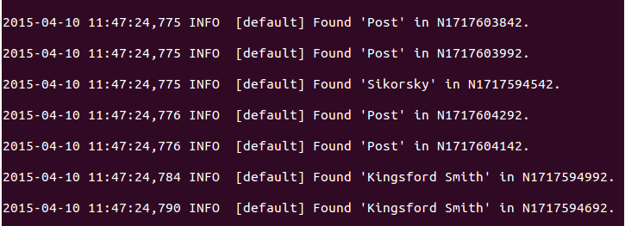

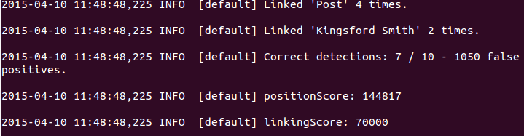

All decimal are truncated in output.
You can also see those results in test_files/output_answer.txt after running all three programs.

Radius and Longitude

The radius and longitude are the two last columns of output in test_files/output_answer_continious.txt.
There are also available in test_files/output_answer.txt

Command Line options and threading

Refer to the respective help of each command and test each command line options.
Add the command line option “-c 4” to use 4 threads.
You should use the full system test to see a noticeable speed improvement over the non threaded version.

Logs and Error Messages

Check the files test_files/output_answer_continious.txt It contains propeller results that are continuously displayed

Also on the standard output, info messages, error messages and debug messages are continuously displayed. Messages in standard output are also available in logs/myeasylog.log

Splitting code in Multiple files

The code has been split in several files. There is a .h and .cpp when relevant to do so.

Speed Comparison

New code is faster than old code. You can run the command line options provided in accuracy subsection preceded by the command “time”.

In our testing we got the following for the previous code

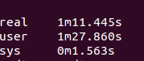

For the new code we got respectively for PropellerTrain, PropellerTest and PropellerStats

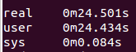

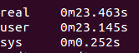

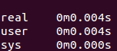

Resource Contact List

Name | Resource Email
yedtoss

